**Ideation Phase**

**Define the Problem Statements**

|  |  |
| --- | --- |
| Date | 31 January 2025 |
| Team ID | PNT2025TMID09657 |
| Project Name | Rentease-HOUSE RENT APP USING MERN |
| Maximum Marks | 2 Marks |

**Customer Problem Statement :**

A Customer Problem Statement for a house rental application identifies the core difficulties and frustrations users face. The key problems include the struggle to find suitable properties that meet their criteria, dealing with inaccurate or outdated listings, and enduring a slow, complex application process. Additionally, users often encounter poor communication with landlords or agents, hidden fees, and a lack of clarity regarding lease terms. This statement's purpose is to define these pain points clearly, so a new or improved application can be designed to directly address and solve them.

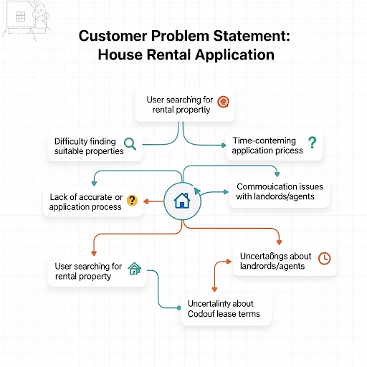

**Example:**

|  |  |  |  |  |  |
| --- | --- | --- | --- | --- | --- |
| **Problem Statement (PS)** | **I am (Customer)** | **I’m trying to** | **But** | **Because** | **Which makes me feel** |
| PS-1 | A prospective tenant searching for a new home | Find a suitable house for rent that fits my budget and location. | The listings are often inaccurate, outdated, or lack essential details and photos. | Landlords and agents do not regularly update the information, and the platform lacks a strong verification process. | Frustrated, like I'm wasting my time, and skeptical of the application's reliability. |
| PS-2 | A potential tenant trying to finalize my rental. | Get clear and timely answers from the landlord or agent about the property and lease terms. | I experience slow response times, and the information I receive is often vague or contradictory. | The platform lacks a centralized communication tool, and the landlord or agent is manually handling multiple inquiries. | Anxious, unconfident in my decision, and distrustful of the rental agreement. |